PRACTICAL – 10

AIM: Use of R markdown and R Studio Cloud

THEORY:

**R Markdown**

R Markdown documents are fully reproducible. Use a productive [notebook interface](https://bookdown.org/yihui/rmarkdown/notebook.html) to weave together narrative text and code to produce elegantly formatted output. Use [multiple languages](https://bookdown.org/yihui/rmarkdown/language-engines.html) including R, Python, and SQL.

R Markdown supports dozens of static and dynamic output formats including [HTML](https://bookdown.org/yihui/rmarkdown/html-document.html), [PDF](https://bookdown.org/yihui/rmarkdown/pdf-document.html), [MS Word](https://bookdown.org/yihui/rmarkdown/word-document.html), [Beamer](https://bookdown.org/yihui/rmarkdown/beamer-presentation.html), [HTML5 slides](https://bookdown.org/yihui/rmarkdown/ioslides-presentation.html), [Tufte-style handouts](https://bookdown.org/yihui/rmarkdown/tufte-handouts.html" \t "_blank), [books](https://bookdown.org/), [dashboards](https://rmarkdown.rstudio.com/flexdashboard/), [shiny applications](https://bookdown.org/yihui/rmarkdown/shiny-documents.html), [scientific articles](https://github.com/rstudio/rticles), [websites](https://bookdown.org/yihui/rmarkdown/rmarkdown-site.html), and more.

R Markdown generates a new file that contains selected text, code, and results from the . Rmd file. The new file can be a finished web page, PDF, MS Word document, slide show, notebook, handout, book, dashboard, package vignette or other format.

**RStudio Cloud**

RStudio Cloud is a lightweight, cloud-based solution that allows anyone to do, share, teach and learn data science online.

RStudio Cloud is portable but it is heavily dependent on an internet connection and the internet speed.

IMPLEMENTATION AND OUTPUT:

1. Login to you RCloud account with either your mail or Google Account

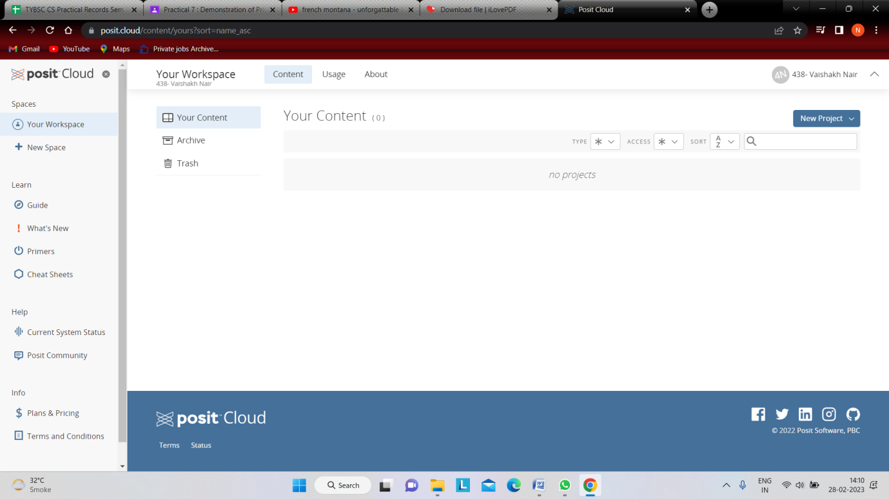

1. Create A NEW PROJECT and Add a NEW RMarkdown

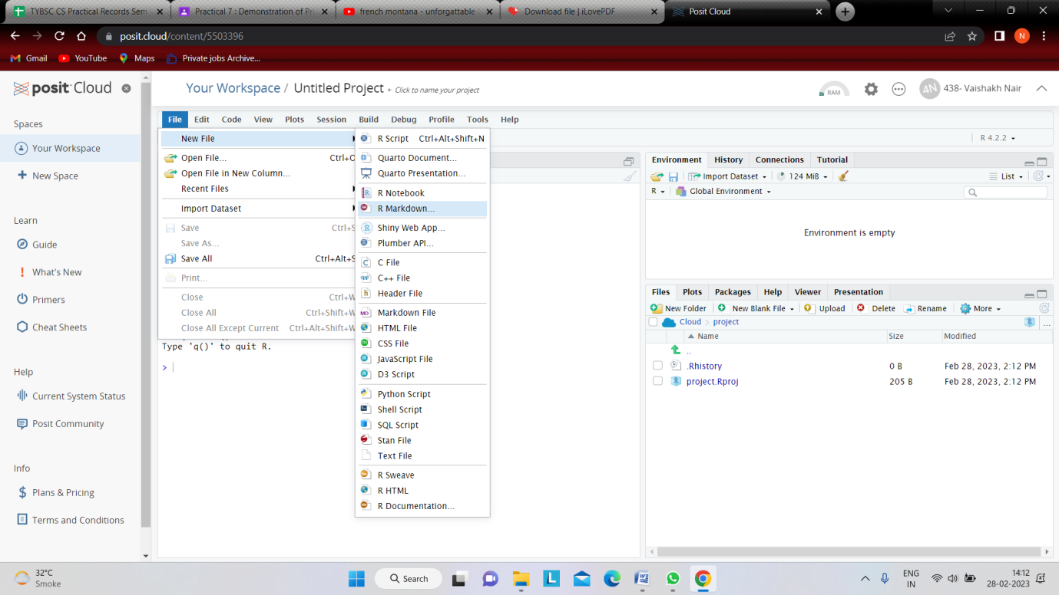

1. Add document name and Author Name and let Default Operation be HTML.

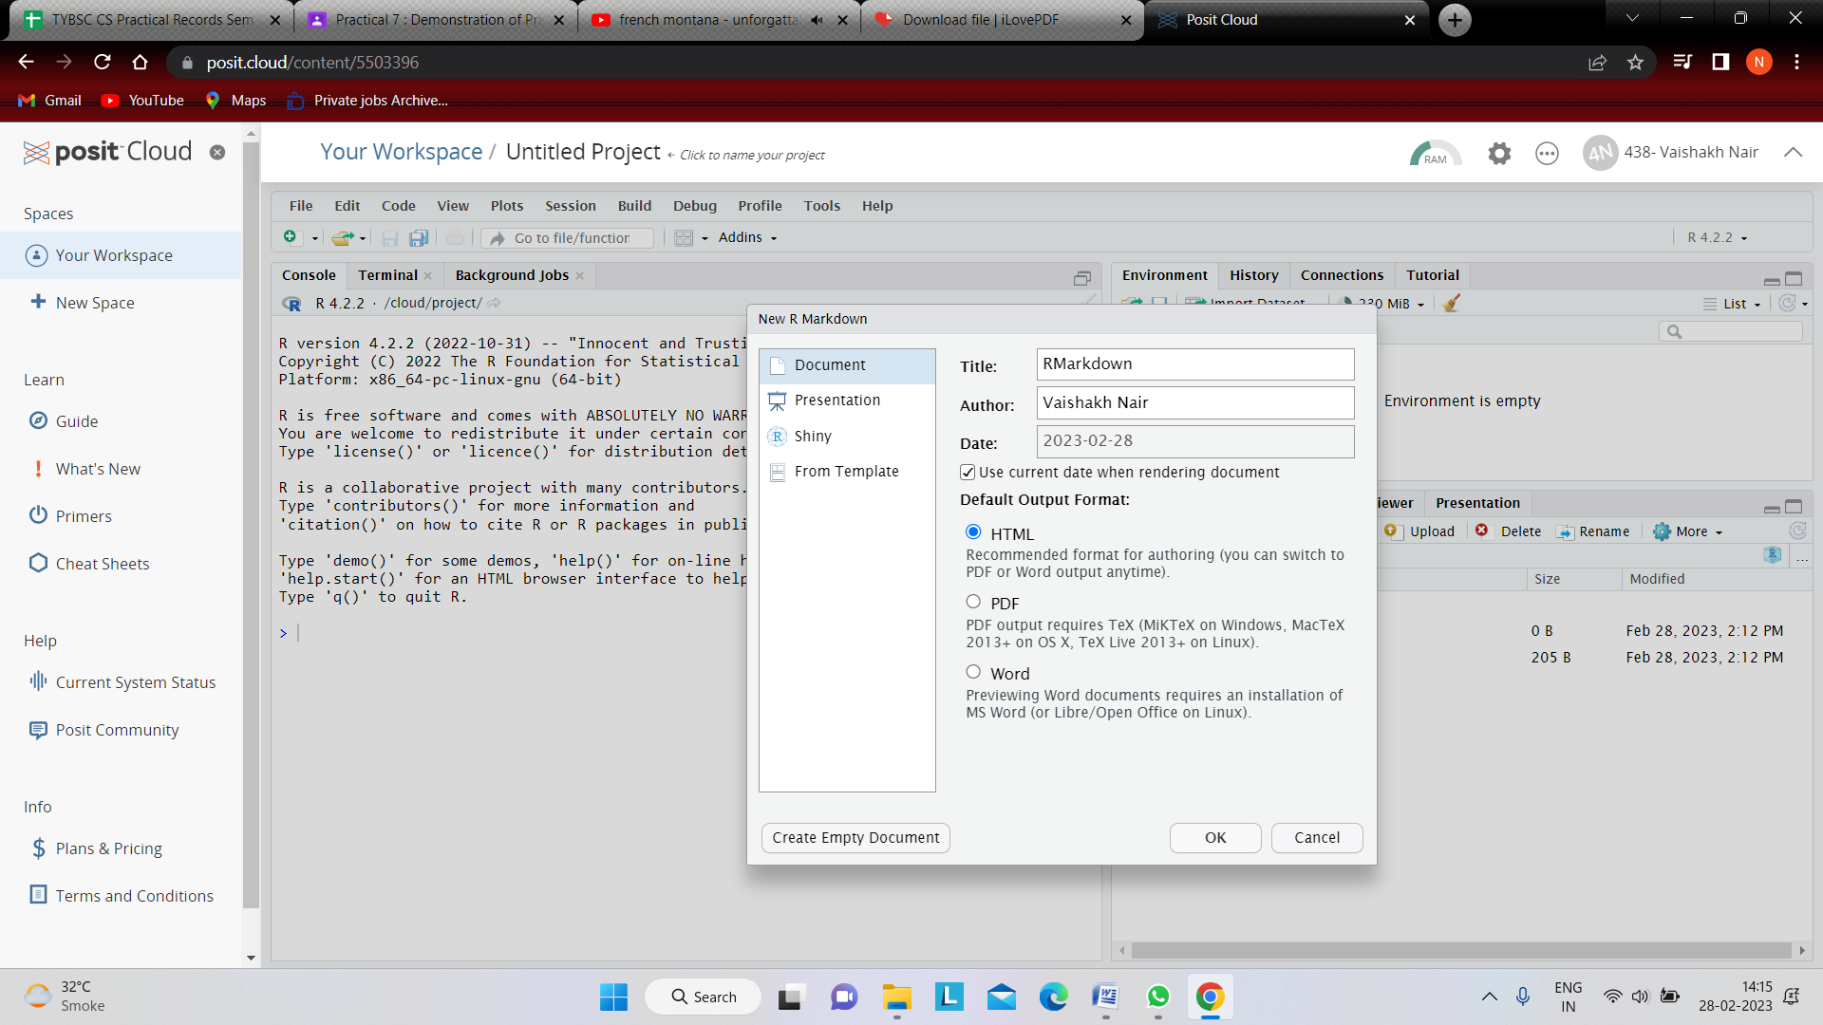

1. Save The Project or Click Knit and The Following Page Will Be Shown.

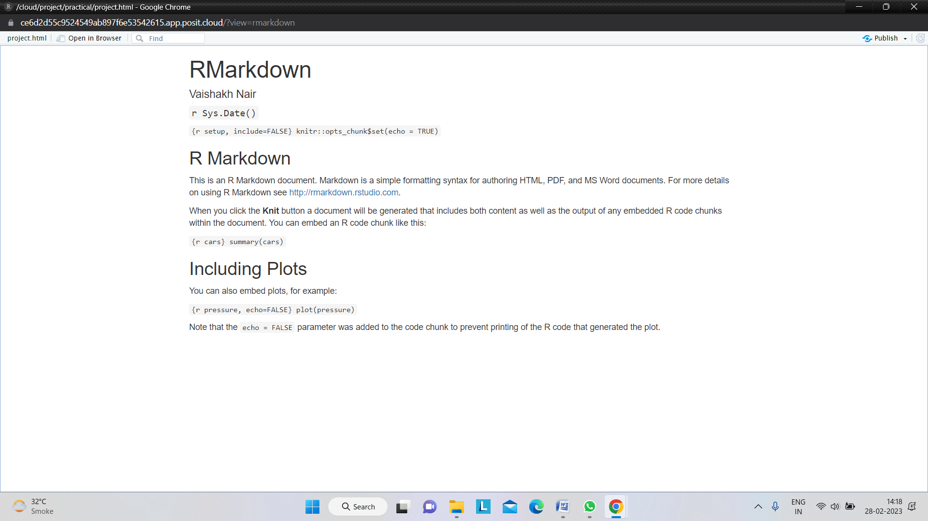

CONCLUSION: Hence we successfully implemented Use of R markdown and R Studio Cloud